28.4: a) Following Example 28.1 we can find the magnetic force between the charges:
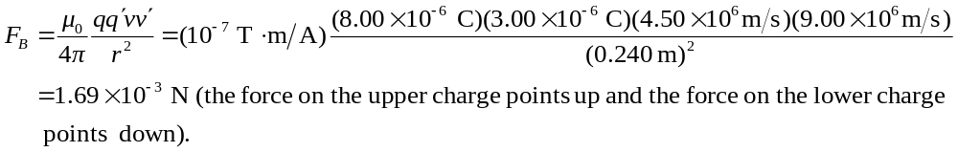The Coulomb force between the charges is
(the force on the upper charge points up and the force on the lower charge points down).
The ratio of the Coulomb force to the magnetic force is 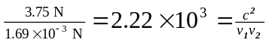.
b) The magnetic forces are reversed when the direction of only one velocity is reversed but the magnitude of the force is unchanged.

